**AWS PAAS/SAAS PROJECT**

This project is a simple multi-tier web application stack built using PAAS/SAAS services on AWS cloud.In this project we have used Tomcat (frontend service) and MySQL,Memcached,RabbitMQ (backend services)

**Benefits of Building the application on AWS are:**

* Scalability
* Pay as you go (this eliminates all the upfront cost for running the application)
* full managed services for running the application
* Reduced Infrastructure Management Overhead
* Rapid Application Deployment
* Automatic Updates and Patch Management

**DIAGRAM WORKFLOW**

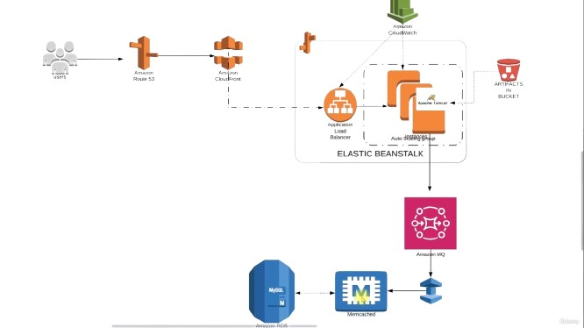

**AWS SERVICES USED:**

* Elastic Beanstalk (for frontend application - Tomcat)
* S3 (storing the artifact)
* Elasticache (for Memcached)
* ActiveMQ (for RabbitMQ)
* RDS (for mysql database)
* CloudFront (for content delivery network)

**FLOW OF EXECUTION**

* Login to AWS account.
* Create Key Pair for Beanstalk instance login.
* Create Security Group for backend services (RDS,Elasticache,ActiveMQ)
* Create RDS,Elasticache (Memcached) and ActiveMQ (RabbitMQ) services in AWS.
* Create Elastic beanstalk Environment
* Update SG of backend to allow traffic from Bean SG
* Update SG of backend to allow internal traffic
* Launch EC2-instance for DB Initializing
* Login to the instance and initialize RDS DB
* Change healthcheck on beanstalk to /login
* Add 443 https listener to ELB
* Build artifact from Backend Information.
* Deploy Artifact to Beanstalk.
* Create CloudFront with SSL certificate
* Create a CNAME record in godaddy for the elastic beanstalk endpoint
* Verify the website.